SQL Assignment: ShopEase Database Analysis
Section A — SQL Basics (SELECT, Constraints, Primary Keys)
Q1. Display all columns and rows from the customers table
ANSWER
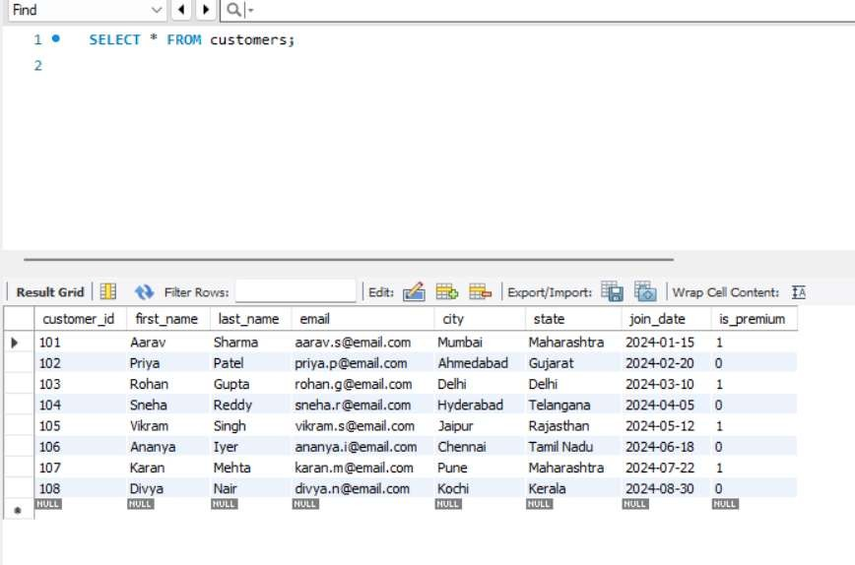
Output
Shows all customer records and all columns.
Explanation
The SELECT * statement retrieves every column and every row from the customers table.

Q2. Retrieve only first_name, last_name, and city of all customers.
ANSWER
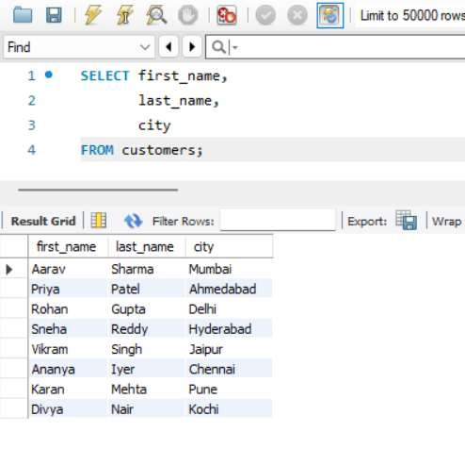
Explanation
Only the specified columns are displayed.

Q3. List all unique categories available in the products table.
ANSWER
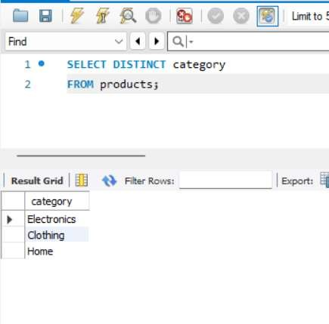
Explanation
DISTINCT removes duplicate values.

Q4. Identify the Primary Key of each table in the schema. Explain why a Primary Key must be unique and NOT NULL.
ANSWER

Table | Primary Key
customers | customer_id
products | product_  id
orders | order_id
order_items | item_id

Explanation
A Primary Key uniquely identifies each record in a table.
- Unique: No two rows can have the same Primary Key value.
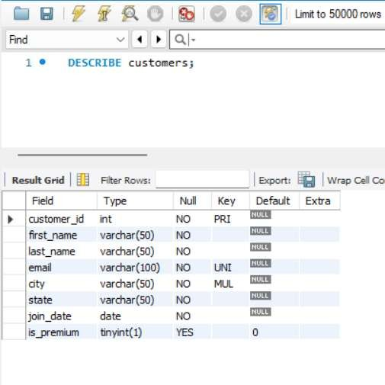
- NOT NULL: Every row must have a Primary Key value; it cannot be empty.
Conclusion
Primary Keys help prevent duplicate records and maintain data integrity in the database.

Q5What constraints are applied to the email column in the customers table? What would happen if you tried to insert a duplicate email?
ANSWER
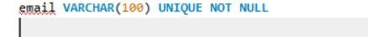
Explanation
The email column has two constraints:
- UNIQUE – No duplicate email addresses are allowed.
- NOT NULL – The email field cannot be empty.
If a duplicate email is inserted, the database will show an error and reject the record because of the UNIQUE constraint.

Q6. Try inserting a product with unit_price = -50. What happens and which constraint prevents it? Write both the INSERT statement and explain the error.
ANSWER
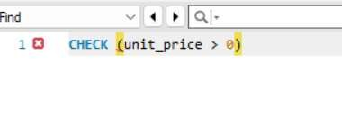
Explanation
The insertion fails because the products table has a CHECK constraint:
CHECK (unit_price > 0)
This constraint ensures that the product price must be greater than 0.
Conclusion
The database rejects the record because -50 is an invalid price and violates the CHECK constraint.

Section B — Filtering & Optimization (WHERE, Indexes)
Q7. Retrieve all orders with status = 'Delivered'.
ANSWER
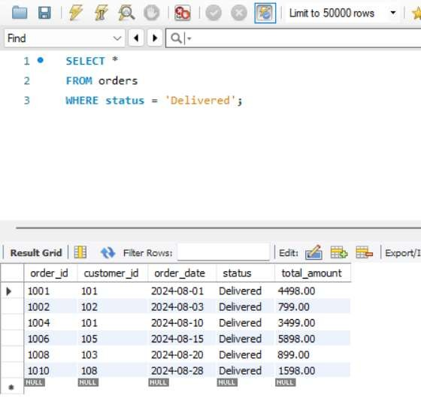
Explanation
The WHERE clause filters the records and displays only orders whose status is Delivered.
Q8. Find all products in the 'Electronics' category with a unit_price greater than ₹2000.
ANSWER
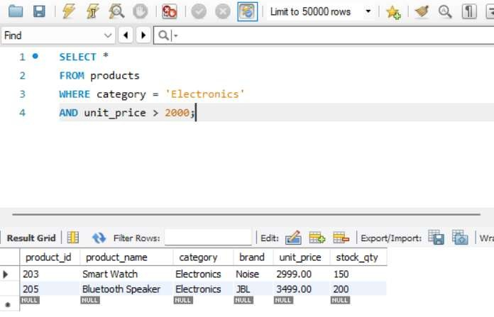
Explanation
This query returns products that belong to the Electronics category and have a price greater than ₹2000.
Q9. List all customers who joined in the year 2024 and belong to the state 'Maharashtra'.
ANSWER
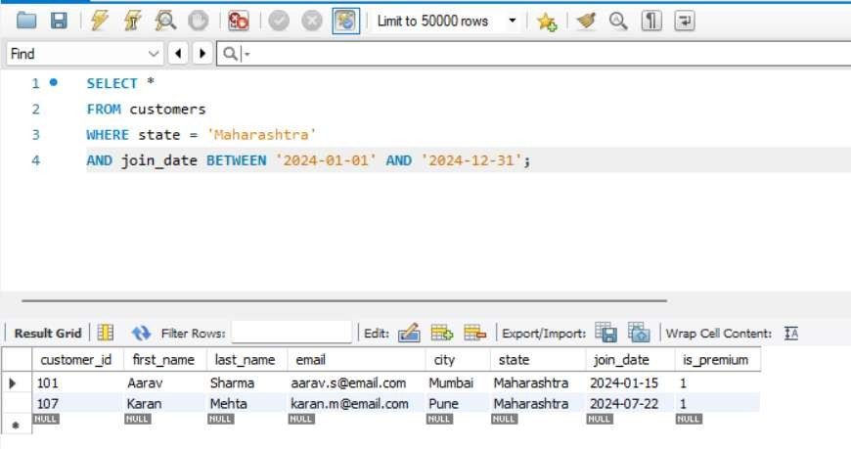
Explanation
The query filters customers from Maharashtra who joined during the year 2024.
Q10. Find all orders placed between '2024-08-10' and '2024-08-25' (inclusive) that are NOT cancelled.
ANSWER
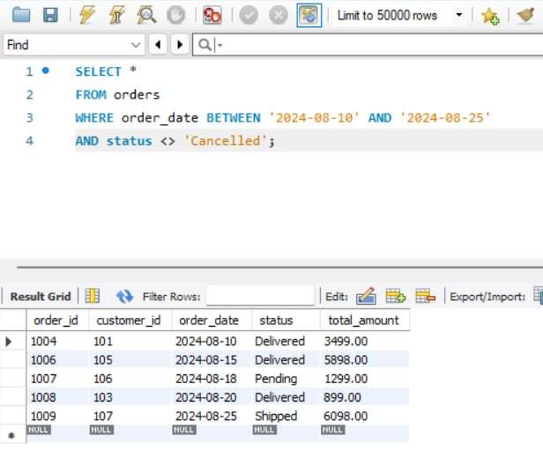
Explanation
BETWEEN selects orders within the date range, and <> 'Cancelled' excludes cancelled orders
Q11. Explain what the index idx_orders_date does. How would it improve the performance of a query that filters orders by order_date? Write a sample query that would benefit from this index.
ANSWER
The index idx_orders_date is created on the order_date column of the orders table.
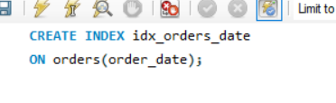
Explanation
An index works like the index of a book. Instead of scanning every row in the table, the database can quickly locate records based on order_date.
This improves query performance, especially when the table contains a large number of records.
Sample Query
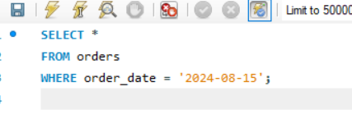
Benefit
The database uses the idx_orders_date index to find matching orders quickly, reducing the time needed to execute the query.
Conclusion
idx_orders_date speeds up searches, filtering, and sorting operations based on the order_date column.

Q12. If you run: SELECT * FROM customers WHERE YEAR(join_date) = 2024; — would the index on join_date be used? Explain why or why not, and rewrite the query to be index-friendly (SARGable).
ANSWER
No, the index on join_date would not be used efficiently because the YEAR() function is applied to the column.
Explanation
When MySQL executes:
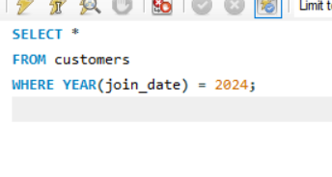
it must calculate the year for every row before filtering, so the index cannot be used effectively.
Index-Friendly (SARGable) Query
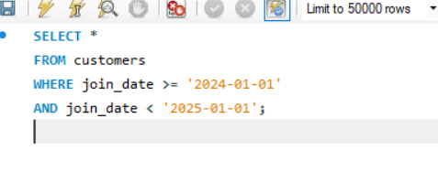
Why is this Better?
This query directly compares the join_date column without using a function, allowing MySQL to use the index and retrieve records faster.
Conclusion
Using a date range is more efficient than using YEAR(join_date) because it allows the database to use the index on join_date, improving query performance

Section C — Aggregation (GROUP BY, SUM, COUNT, AVG, MIN, MAX)
Q13. Count the total number of orders in the orders table.
ANSWER
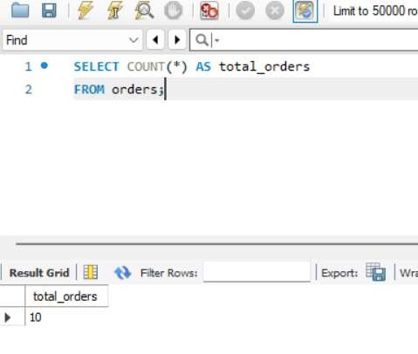
Explanation
COUNT(*) counts all rows in the orders table.
Conclusion
There are 10 orders in the database.
Q14. Find the total revenue (SUM of total_amount) from all 'Delivered' orders.
ANSWER
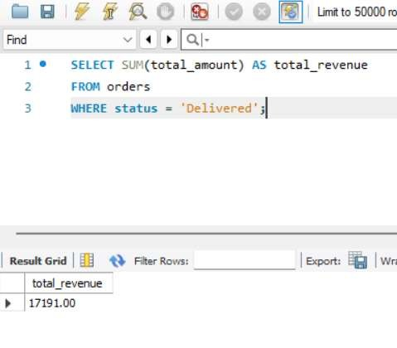
Explanation
SUM() adds the total_amount of all orders with status = 'Delivered'.
Conclusion
The total revenue from delivered orders is ₹17,191.
Q15. Calculate the average unit_price of products in each category.
ANSWER
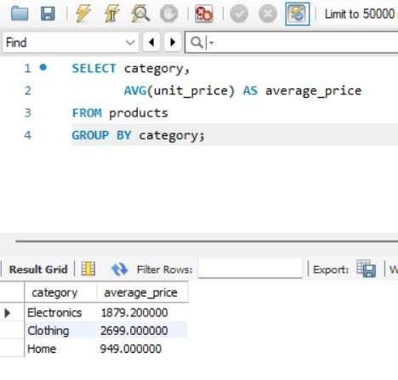
Explanation
AVG() calculates the average price, and GROUP BY groups products by category.
Conclusion
This shows the average product price for each category.
Q16. For each order status, find the count of orders and the total revenue. Sort the result by total revenue in descending order.
ANSWER
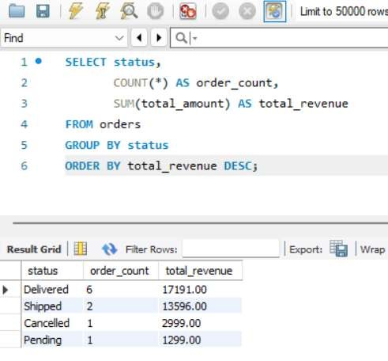
Explanation
- COUNT(*) counts orders.
- SUM() calculates revenue.
- ORDER BY sorts revenue from highest to lowest.
Conclusion
Delivered orders generated the highest revenue.
Q17. Find the most expensive (MAX) and cheapest (MIN) product in each category.
ANSWER
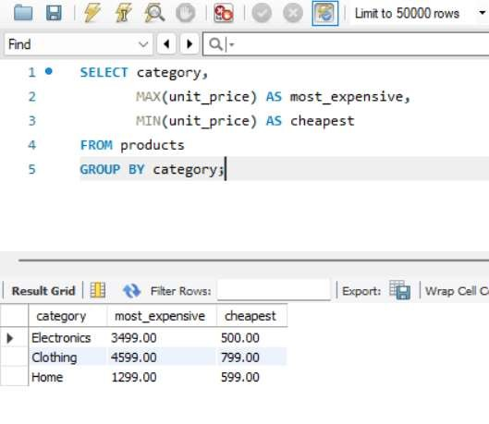
Explanation
- MAX() finds the highest price.
- MIN() finds the lowest price.
- GROUP BY performs the calculation for each category.
Conclusion
This query identifies the price range within each category.
Q18. List all product categories where the average unit_price is greater than ₹2000.
ANSWER
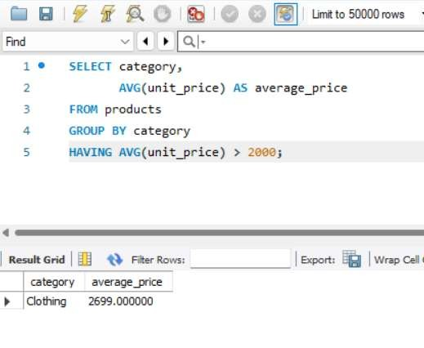
Explanation
HAVING filters grouped results based on the average price.
Conclusion
Only Clothing have an average product price greater than ₹2000.

Section D — Joins & Relationships
Q19. Write an INNER JOIN query to display each order along with the customer's first_name and last_name. Show: order_id, order_date, first_name, last_name, total_a mount.

ANSWER
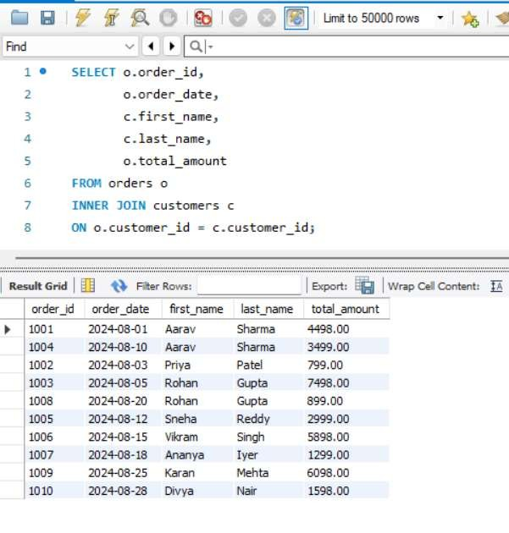
Explanation
INNER JOIN combines records from orders and customers where customer_id matches.
Conclusion
This query shows order details along with customer names.
Q20. Using a LEFT JOIN, list ALL customers and their orders (if any).
Customers with no orders should still appear with NULL values for order columns.
ANSWER
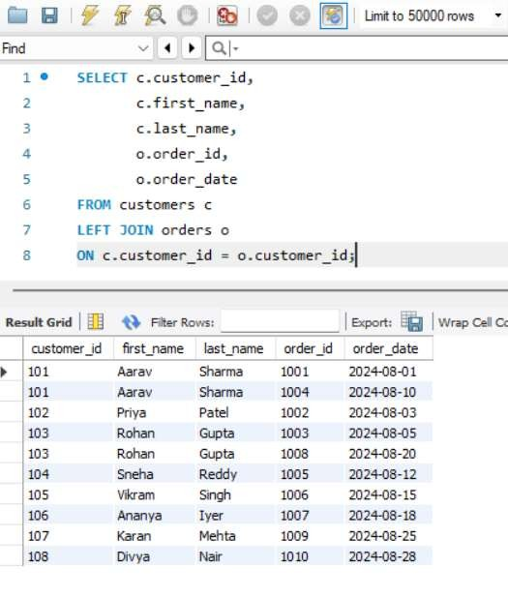
Explanation
LEFT JOIN displays all customers and their orders. If a customer has no order, the order columns show NULL.
Conclusion
Useful for finding customers who have not placed any orders.
Q21. Show order_id, product_name, quantity, unit_price, and discount_pct for each order item.
ANSWER
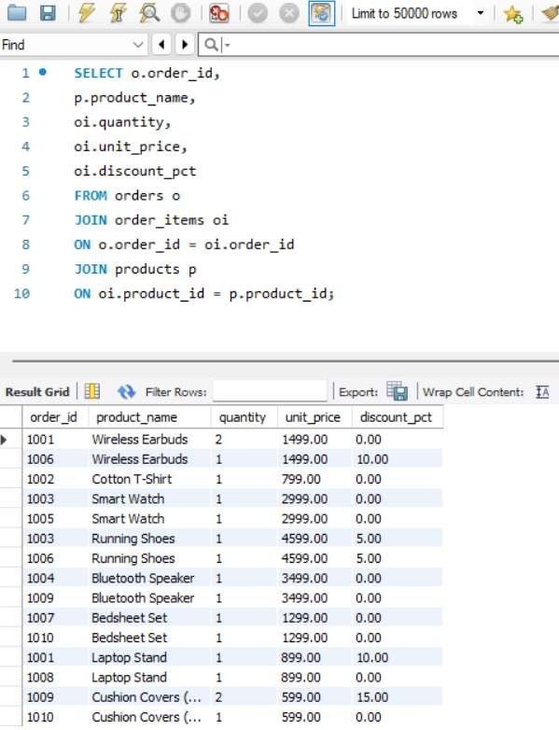
Explanation
This query joins orders, order_items, and products to display complete order item details.
Conclusion
It provides detailed information about products purchased in each order.
Q22. Explain the difference between LEFT JOIN and RIGHT JOIN. When would you use a FULL OUTER JOIN?
ANSWER
LEFT JOIN
Returns all records from the left table and matching records from the right table.
Example:
SELECT *
FROM customers c
LEFT JOIN orders o
ON c.customer_id = o.customer_id;
RIGHT JOIN
Returns all records from the right table and matching records from the left table.
Example:
SELECT *
FROM customers c
RIGHT JOIN orders o
ON c.customer_id = o.customer_id;
FULL OUTER JOIN
Returns all records from both tables, including unmatched rows.
Conclusion
- LEFT JOIN → All rows from left table.
- RIGHT JOIN → All rows from right table.
- FULL OUTER JOIN → All rows from both tables.

Q23. Identify all Foreign Key relationships in the schema. Explain what would happen if you tried to insert an order with customer_id = 999 (which doesn't exist in customers).
ANSWER
Foreign Key Relationships
Parent Table | Child Table | Foreign Key
customers | orders | customer_id
orders | order_items | order_id
products | order_items | product_id
Example
INSERT INTO orders
VALUES
(1011, 999, '2024-09-01', 'Pending', 1000.00);
Output
ERROR: Foreign Key Constraint Failed
Explanation
customer_id = 999 does not exist in the customers table. Since orders.customer_id is a Foreign Key referencing customers.customer_id, the database will reject the insertion.
Conclusion
The order will not be inserted because the Foreign Key constraint ensures that every order must belong to an existing customer.

Section E — Advanced Concepts (CASE, ACID, Transactions)
Q24. Write a query using CASE to classify products into price tiers.
ANSWER
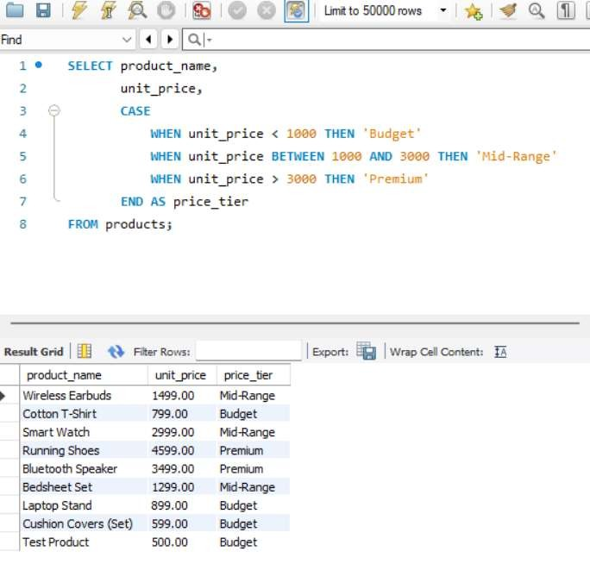
Explanation
The CASE statement classifies products into:
- Budget (< ₹1000)
- Mid-Range (₹1000–₹3000)
- Premium (> ₹3000)
Conclusion
This helps categorize products based on price.

Q25. Using a CASE statement inside an aggregate function, count how many orders are 'Delivered' vs 'Not Delivered'.
ANSWER
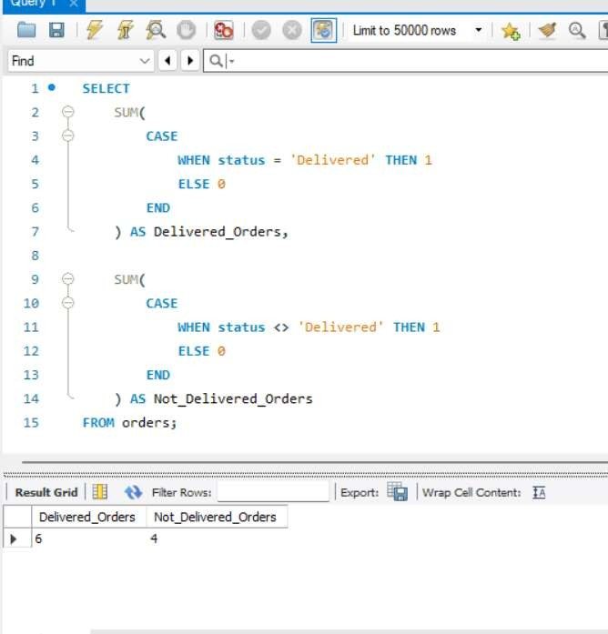
Explanation
- Delivered orders = 6
- Not Delivered orders = 4
Conclusion
The company has more delivered orders than pending, shipped, or cancelled orders.

Q26. Explain each letter of ACID.
Answer
A – Atomicity
All operations in a transaction happen completely or not at all.
Example: In a bank transfer, money is deducted from one account and added to another. If one step fails, the whole transaction is cancelled.

C – Consistency
The database remains correct before and after the transaction.
Example: Total money in the bank remains the same after a transfer.

I – Isolation
Multiple transactions do not interfere with each other.
Example: Two customers transferring money at the same time do not affect each other's transactions.

D – Durability
Once a transaction is committed, it is permanently saved.
Example: After a successful bank transfer, the data remains saved even if the system crashes.
Conclusion
ACID properties ensure reliable and accurate database transactions.

Q27. Write a SQL transaction that inserts a new order, inserts order items, updates stock, and uses COMMIT/ROLLBACK.
ANSWER
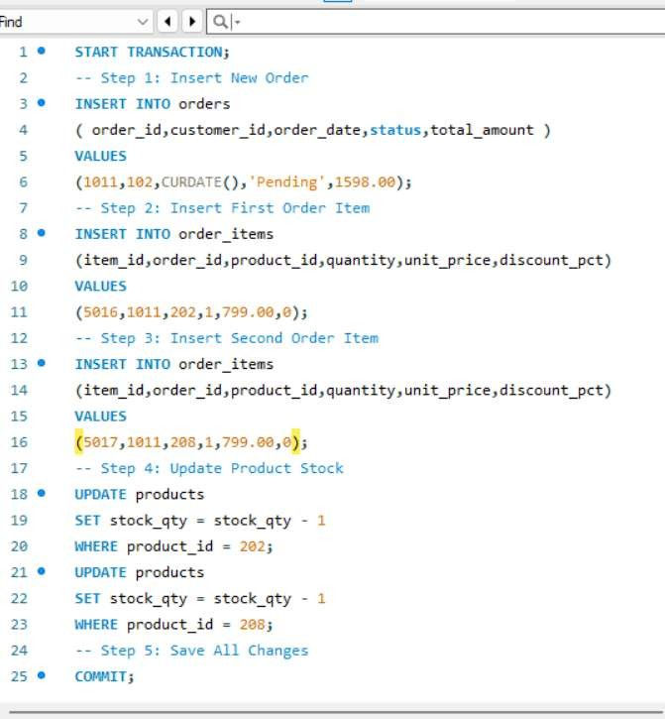
OUTPUT
If Any Error Occurs
ROLLBACK;
Explanation
- A new order is created.
- Two order items are added.
- Product stock is reduced.
- COMMIT saves all changes.
- ROLLBACK cancels all changes if an error occurs.
Conclusion
Transactions ensure that all operations succeed together or fail together, keeping the database consistent and accurate.

